Spread operator does shallow copy (поверхностное копирование)

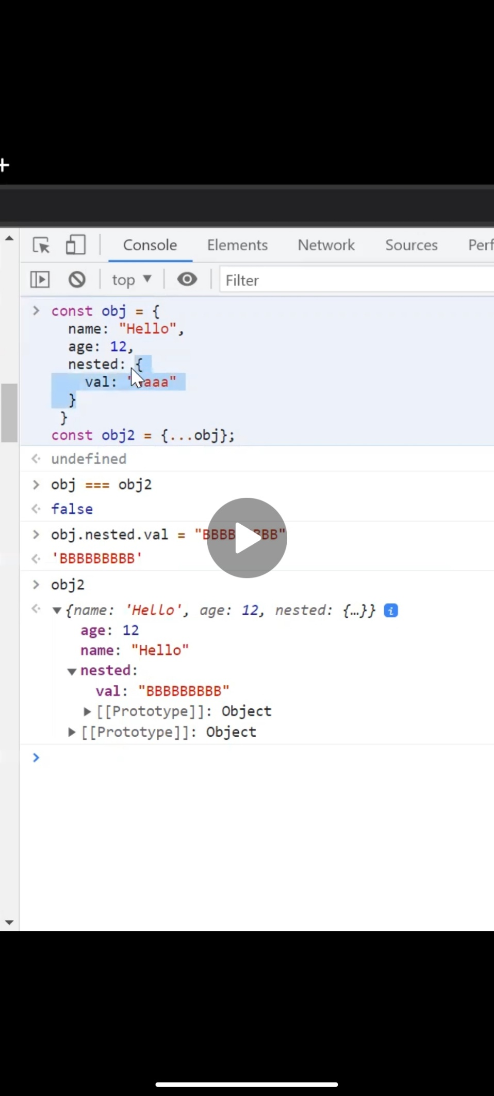

For obj and obj2 new memory is allocated

But its nested objects are not allocated new memory space. So, changing nested objects val will also affect obj2.nested.val